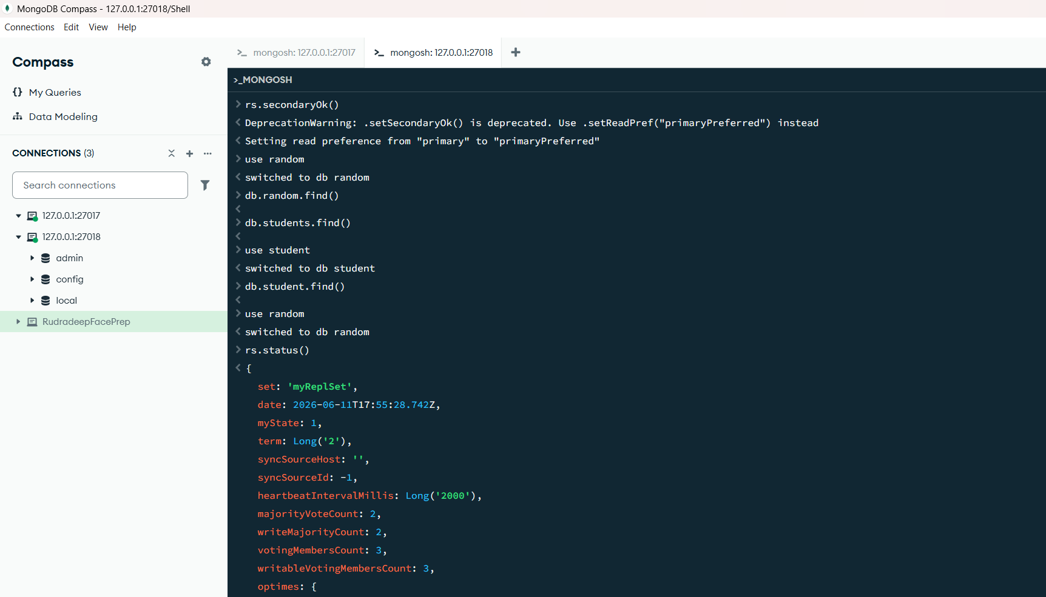
rs.initiate({
_id: "myReplSet",
members: [
{ _id: 0, host: "localhost:27017" },
{ _id: 1, host: "localhost:27018" },
{ _id: 2, host: "localhost:27019" }
]
})
{for port sd

Ffor port …17
ok: 1,
'$clusterTime': {
clusterTime: Timestamp({ t: 1781200335, i: 1 }),
signature: {
hash: Binary.createFromBase64('AAAAAAAAAAAAAAAAAAAAAAAAAAA=', 0),
keyId: Long('0')
}
},
operationTime: Timestamp({ t: 1781200335, i: 1 })
}
rs.status()
{
state: 2,
stateStr: 'SECONDARY',
uptime: 14,
optime: { ts: Timestamp({ t: 1781200346, i: 17 }), t: Long('1') },
optimeDurable: { ts: Timestamp({ t: 1781200346, i: 17 }), t: Long('1') },
optimeWritten: { ts: Timestamp({ t: 1781200346, i: 17 }), t: Long('1') },
optimeDate: 2026-06-11T17:52:26.000Z,
optimeDurableDate: 2026-06-11T17:52:26.000Z,
optimeWrittenDate: 2026-06-11T17:52:26.000Z,
lastAppliedWallTime: 2026-06-11T17:52:26.807Z,
lastDurableWallTime: 2026-06-11T17:52:26.807Z,
lastWrittenWallTime: 2026-06-11T17:52:26.807Z,
lastHeartbeat: 2026-06-11T17:52:28.620Z,
lastHeartbeatRecv: 2026-06-11T17:52:29.633Z,
pingMs: Long('0'),
lastHeartbeatMessage: '',
syncSourceHost: 'localhost:27017',
syncSourceId: 0,
infoMessage: '',
configVersion: 1,
configTerm: 1
},
{
_id: 2,
name: 'localhost:27019',
health: 1,
state: 2,
stateStr: 'SECONDARY',
uptime: 14,
optime: { ts: Timestamp({ t: 1781200346, i: 17 }), t: Long('1') },
optimeDurable: { ts: Timestamp({ t: 1781200346, i: 17 }), t: Long('1') },
optimeWritten: { ts: Timestamp({ t: 1781200346, i: 17 }), t: Long('1') },
optimeDate: 2026-06-11T17:52:26.000Z,
optimeDurableDate: 2026-06-11T17:52:26.000Z,
optimeWrittenDate: 2026-06-11T17:52:26.000Z,
lastAppliedWallTime: 2026-06-11T17:52:26.807Z,
lastDurableWallTime: 2026-06-11T17:52:26.807Z,
lastWrittenWallTime: 2026-06-11T17:52:26.807Z,
lastHeartbeat: 2026-06-11T17:52:28.620Z,
lastHeartbeatRecv: 2026-06-11T17:52:29.649Z,
pingMs: Long('0'),
lastHeartbeatMessage: '',
syncSourceHost: 'localhost:27017',
syncSourceId: 0,
infoMessage: '',
configVersion: 1,
configTerm: 1
}
],
ok: 1,
'$clusterTime': {
clusterTime: Timestamp({ t: 1781200346, i: 17 }),
signature: {
hash: Binary.createFromBase64('AAAAAAAAAAAAAAAAAAAAAAAAAAA=', 0),
keyId: Long('0')
}
},
operationTime: Timestamp({ t: 1781200346, i: 17 })
}
use random

db.students.insertOne({
name: "Ruddradeep",
course: "MongoDB"
})
switched to db random
rs.status()
MongoServerSelectionError: connect ECONNREFUSED 127.0.0.1:27017
Ffor port …18
rs.secondaryOk()
DeprecationWarning: .setSecondaryOk() is deprecated. Use .setReadPref("primaryPreferred") instead
Setting read preference from "primary" to "primaryPreferred"
use random
switched to db random
db.random.find()
db.students.find()
use student
switched to db student
db.student.find()
use random
switched to db random
rs.status()
{
optimeWritten: { ts: Timestamp({ t: 1781200525, i: 9 }), t: Long('2') },
optimeWrittenDate: 2026-06-11T17:55:25.000Z,
lastAppliedWallTime: 2026-06-11T17:55:25.680Z,
lastDurableWallTime: 2026-06-11T17:55:25.680Z,
lastWrittenWallTime: 2026-06-11T17:55:25.680Z,
syncSourceHost: '',
syncSourceId: -1,
infoMessage: '',
electionTime: Timestamp({ t: 1781200501, i: 1 }),
electionDate: 2026-06-11T17:55:01.000Z,
configVersion: 1,
configTerm: 2,
self: true,
lastHeartbeatMessage: ''
},
{
_id: 2,
name: 'localhost:27019',
health: 1,
state: 2,
stateStr: 'SECONDARY',
uptime: 192,
optime: { ts: Timestamp({ t: 1781200525, i: 9 }), t: Long('2') },
optimeDurable: { ts: Timestamp({ t: 1781200525, i: 9 }), t: Long('2') },
optimeWritten: { ts: Timestamp({ t: 1781200525, i: 9 }), t: Long('2') },
optimeDate: 2026-06-11T17:55:25.000Z,
optimeDurableDate: 2026-06-11T17:55:25.000Z,
optimeWrittenDate: 2026-06-11T17:55:25.000Z,
lastAppliedWallTime: 2026-06-11T17:55:25.680Z,
lastDurableWallTime: 2026-06-11T17:55:25.680Z,
lastWrittenWallTime: 2026-06-11T17:55:25.680Z,
lastHeartbeat: 2026-06-11T17:55:28.096Z,
lastHeartbeatRecv: 2026-06-11T17:55:28.716Z,
pingMs: Long('0'),
lastHeartbeatMessage: '',
syncSourceHost: 'localhost:27018',
syncSourceId: 1,
infoMessage: '',
configVersion: 1,
configTerm: 2
}
],
ok: 1,
'$clusterTime': {
clusterTime: Timestamp({ t: 1781200525, i: 9 }),
signature: {
hash: Binary.createFromBase64('AAAAAAAAAAAAAAAAAAAAAAAAAAA=', 0),
keyId: Long('0')
}
},
operationTime: Timestamp({ t: 1781200525, i: 9 })
}
db
random
the survival point after closing one of the window is still active

